**DevOps Certification Training**

**Kubernetes Assignment 1**

Done by

Sruthi Motepalli

You are working for an MNC company, the company is struggling with managing containers, Scaling up or scaling down their containerized application, they need an orchestration solution to manage their container deployments. They have decided to use Kubernetes. As a DevOps engineer, you are requested to execute the following task.

1. Install minikube on a machine.

Installed Docker Desktop

Then ran these commands on PowerShell to install minikube:

--->New-Item -Path 'c:\' -Name 'minikube' -ItemType Directory -Force

Invoke-WebRequest -OutFile 'c:\minikube\minikube.exe' -Uri 'https://github.com/kubernetes/minikube/releases/latest/download/minikube-windows-amd64.exe' -UseBasicParsing

---> $oldPath = [Environment]::GetEnvironmentVariable('Path', [EnvironmentVariableTarget]::Machine)

if ($oldPath.Split(';') -inotcontains 'C:\minikube'){ `

[Environment]::SetEnvironmentVariable('Path', $('{0};C:\minikube' -f $oldPath), [EnvironmentVariableTarget]::Machine) `

}

2. Start minikube cluster.

---> minikube start

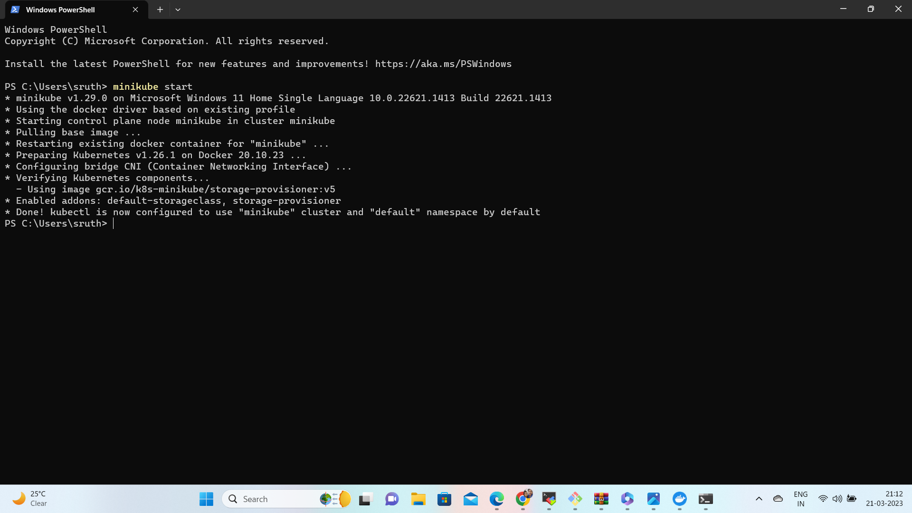

3. Write a deployment.yml file to deploy addressbook application.

In Git Bash, I created a file Deploy.yml in the minikubefolder with the following content.

Command used: vi Deploy.yml

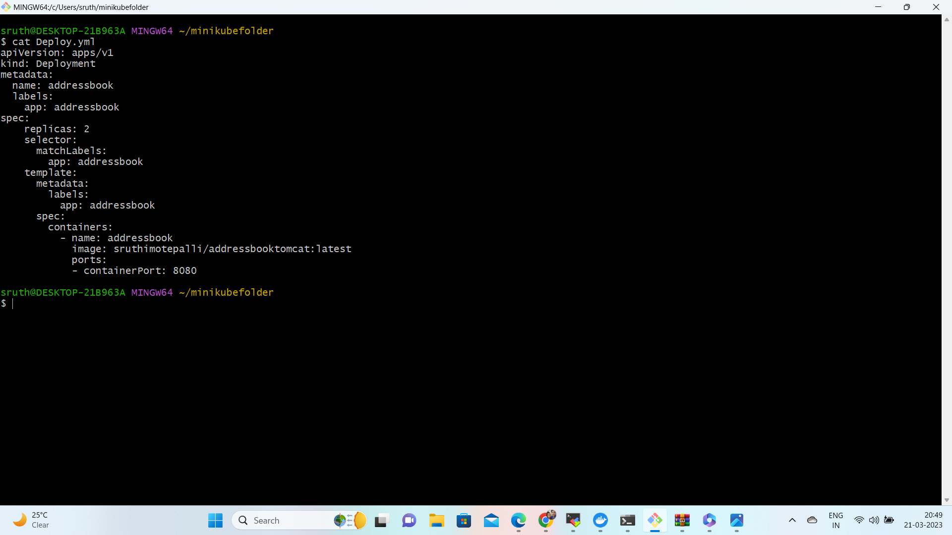

4. Create the deployment with deployment.yml.

In PowerShell started minikube.

Commands: kubectl create –f Deploy.yml

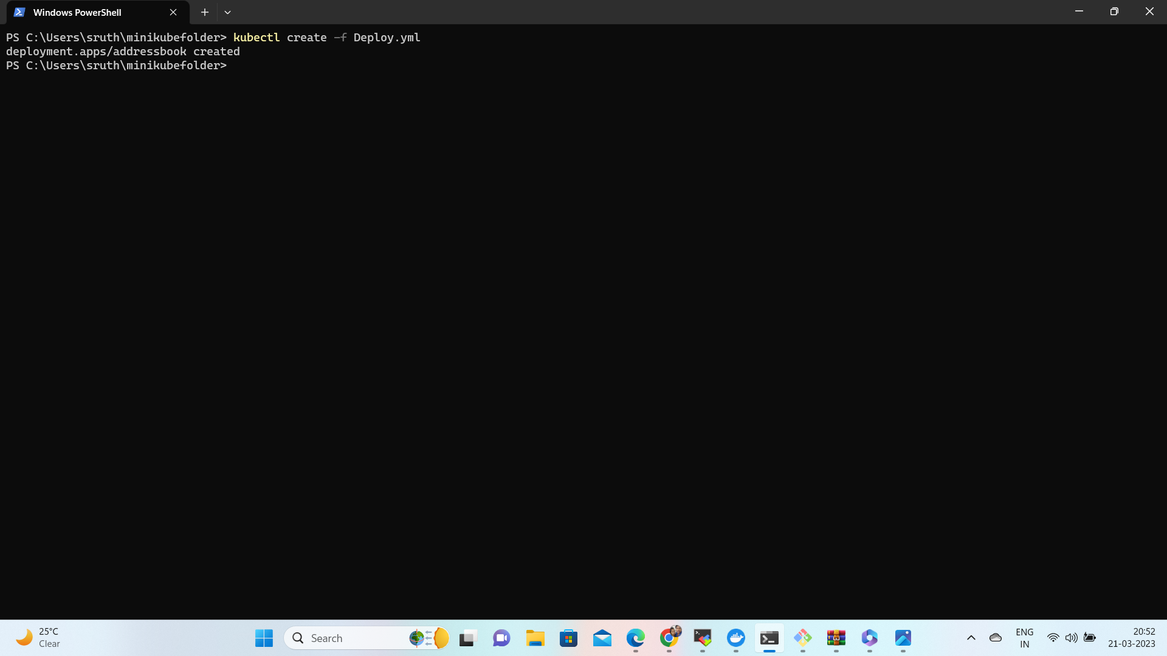

5. Scale up the addressbook application up to 10 instances.

Command used to scale up: kubectl scale --replicas=10 deployment addressbook

kubectl get pods

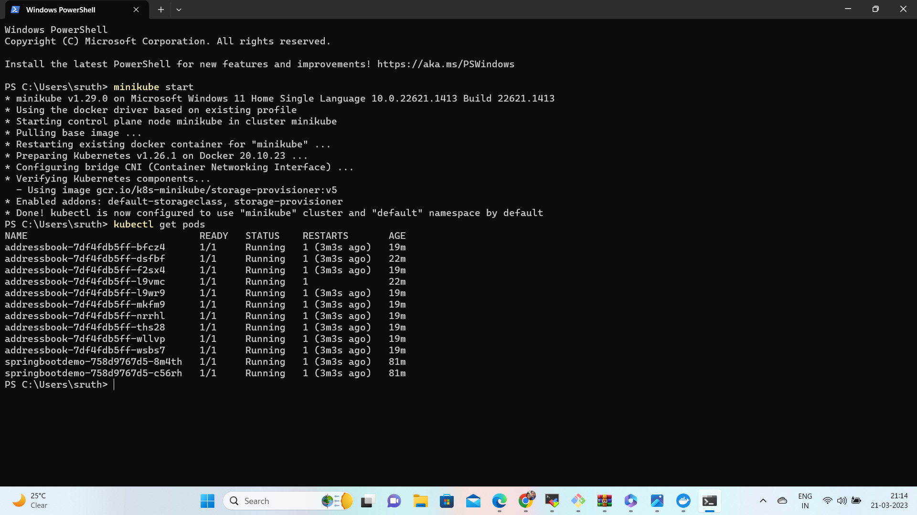

6. Scale down the addressbook application to 1 instance

kubectl scale --replicas=1 deployment addressbook

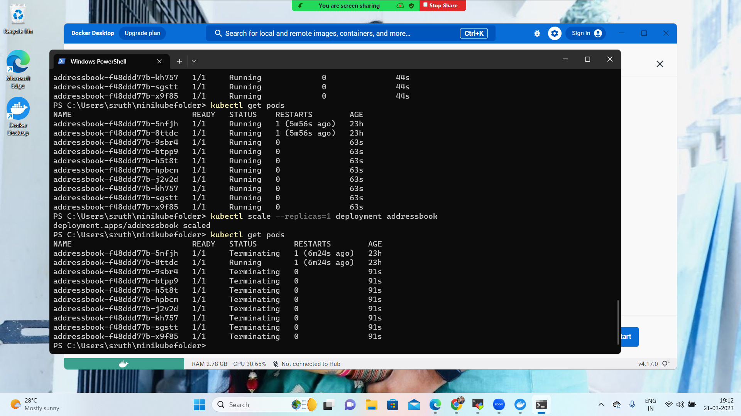

7. Create a service to expose your addressbook application.

Write a Service.yml file with the contents below.

Commands used: vi Service.yml

kubectl create –f Service.yml

kubectl get svc/service

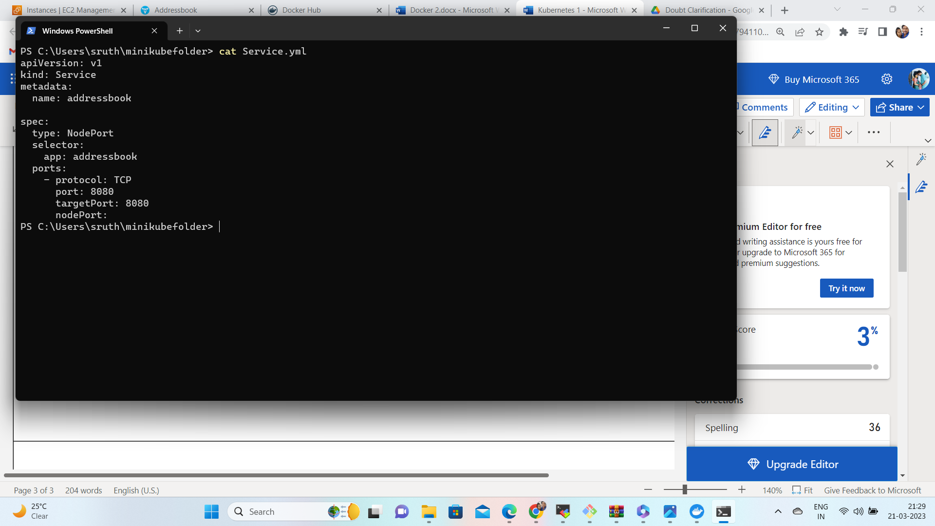

8. Verify your application.

Commands used: minikube service addressbook url

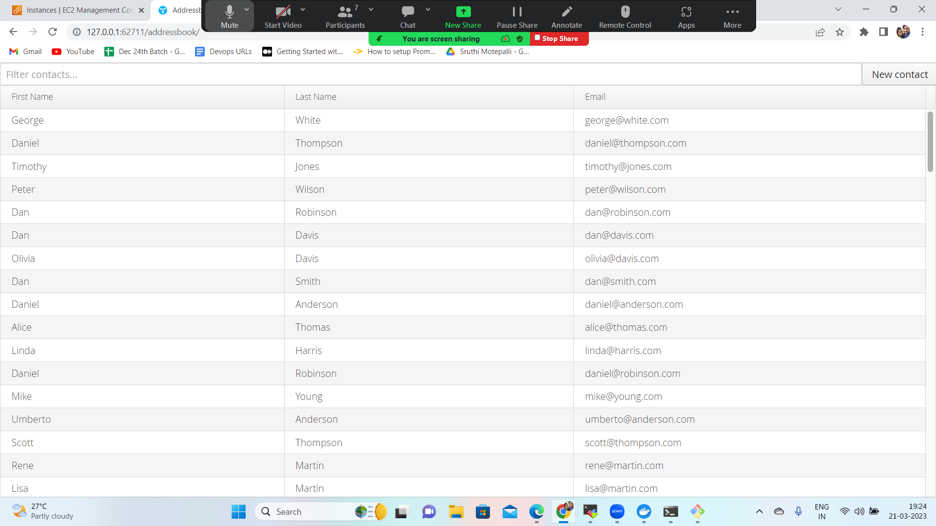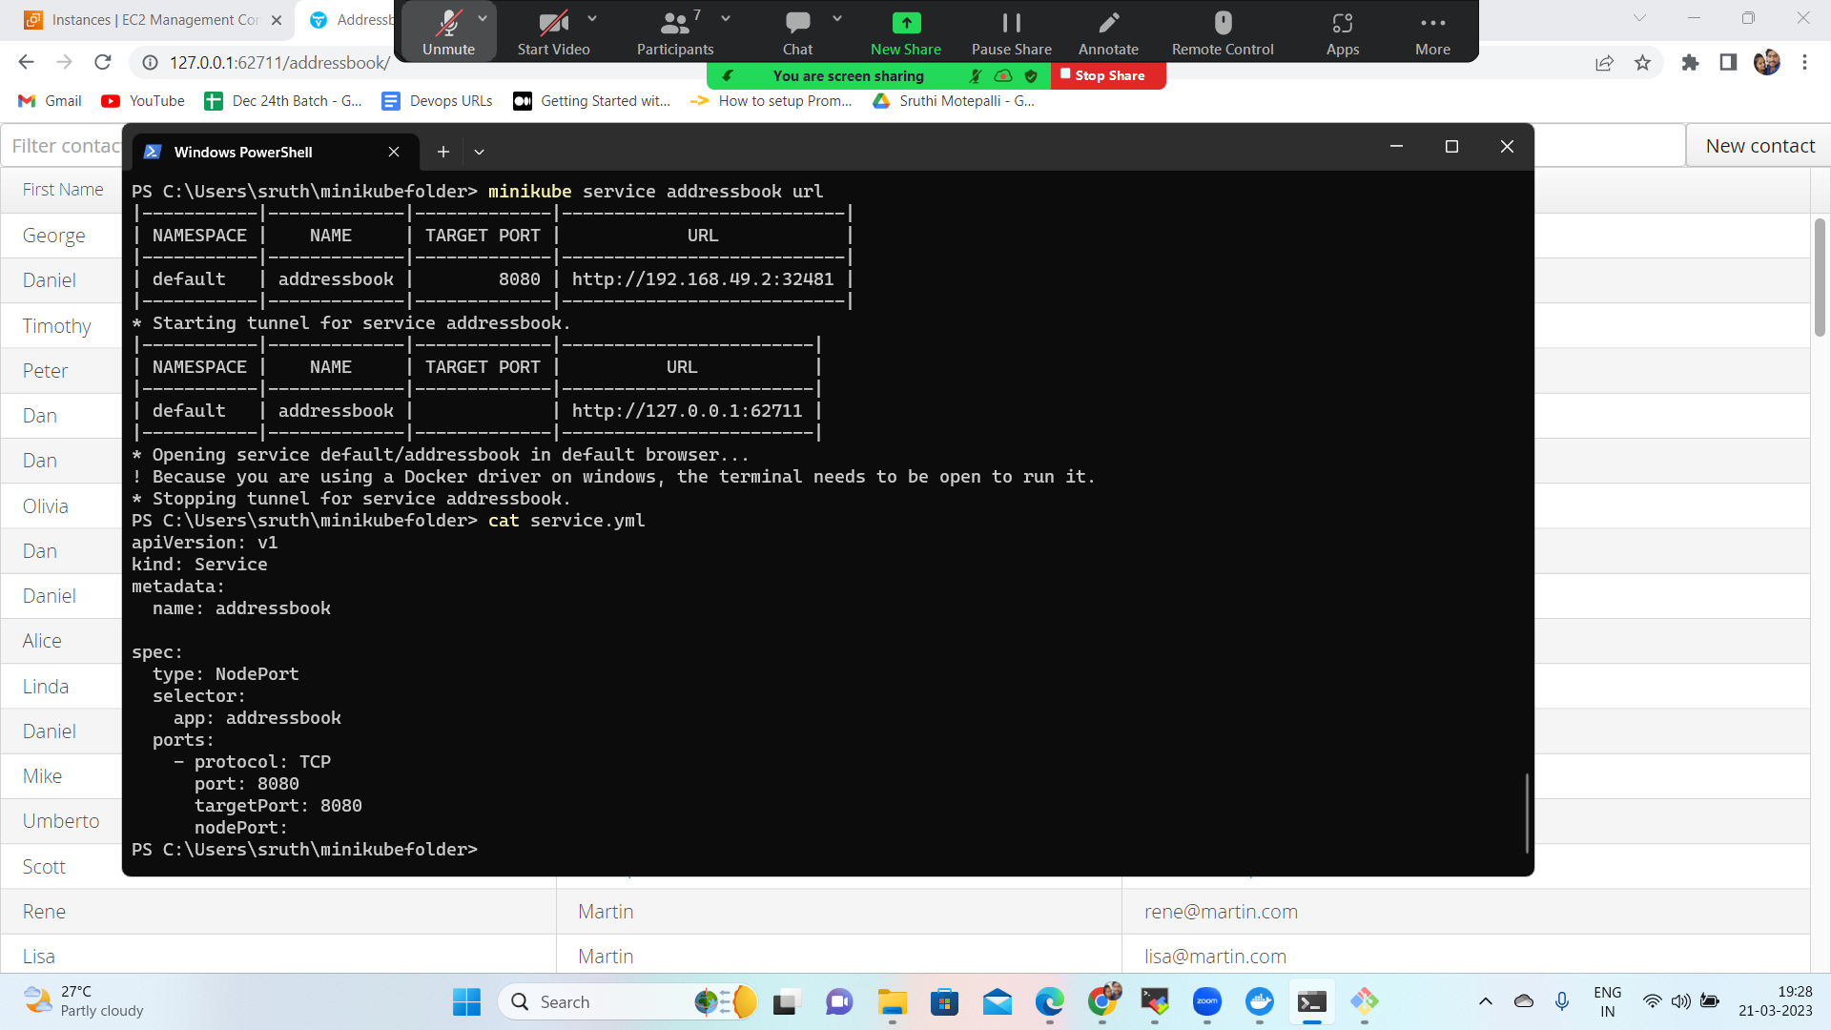

----------------------------------------------END---------------------------------------------------